HELP FIND LINDSEY BAUM
Missing since 6/26/2009

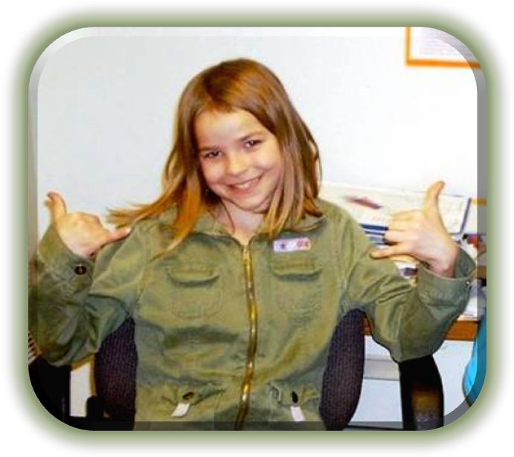
Searchers Needed
SATURDAYS & SUNDAYS
Through the Month of October
Help us bring Lindsey Home!

WHERE: 303 4TH AVENUE MCCLEARY WA (4TH & FIR – in the trailer behind the church)
TIME: 9:00am - 4:30pm RAIN OR SHINE!!!
Searches will begin at 9:00 am and last search will be sent out at 4:00 pm. Please come and help all day, part day or even a couple of hours. ANY help is appreciated. Off-road vehicles, quads, horses, boats are welcome and needed.

Volunteers are asked to wear weather and search appropriate clothing. There may be areas in thick brush as well as rough terrain so good shoes and long sleeves and pants are being suggested.

There is also a need of volunteers inside the search center for varying tasks and errands. Please check in at the search center or email questions to contact@findlindseybaum.com or you can call 360-495-3400, 360-495-4100

Donations of snacks, beverages, food for searchers, disposable cups & toilet paper are needed. If you are unable to deliver supplies please let us know and we will make arrangements for someone to pick them up.
Please ask friends, family, co-workers to join us in our search for Lindsey.

Thank you to everyone who has supported our search for this precious missing child.

